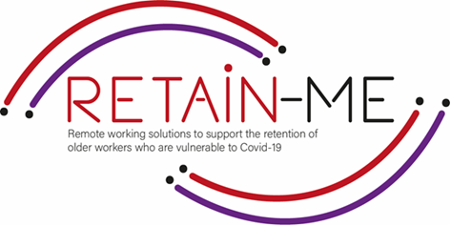

**EMBRACING CHANGE FACT SHEET**

**UNDERSTAND AND DEVELOPMENT OF CREATIVE PROBLEM SOLVING**

**SELF-REFLECTION EXCERCISES**

Creative problem solving is innovative problem solving. A creative problem solver often finds completely new solutions rather than simply identifying and implementing normal solutions.

*“Every problem has a solution. You just have to be creative enough to find it.”-Travis Kalanick*

Self-reflection about the knowledge and what we need to improve concerning creative problem solving.

# FACTS

# Self-reflection is very important to know if we are understanding creative problem solving

1. Indicate which statement is right and which is wrong

|  |  |  |
| --- | --- | --- |
| Statement | R | W |
| 1. Creative problem solving is not a process. |  | X |
| 1. Problem-solving activity helps to builds problem-solving skills | X |  |
| 1. Its not important to develop problem solving skills |  | X |
| 1. Creative problem solving is innovative problem solving. | X |  |
| All problem-solving processes start with identifying the problem. | X |  |

1. Find the statement that does not indicate a good practice

to creative problem solving.

|  |
| --- |
| Work in team. |
| 1. Find good methods for creative problem solving |
| 1. Follow a plan |
| 1. Accept solutions |
| 1. Don’t identify the problem |

1. Find what does not support creative problem solving.

|  |
| --- |
| 1. Open minded. |
| 1. See opportunities |
| 1. Increase problem solving skills |
| 1. See problems as roadblocks |
| 1. Develops personalities |

# *"The win/win law is: Let's not do it your way or my way, let's do it the best way."*

*Greg Anderson*



For more information, you may visit our website: <https://retain-me.eu/>

and our Facebook: <https://www.facebook.com/RetainMeErasmusProject>



2021-1-SE01-KA220-VET-000032922