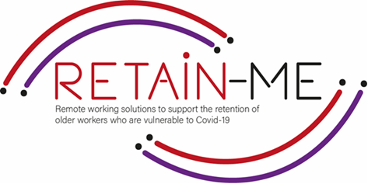

**EMBRACING CHANGE FACT SHEET**

**Understand and development of creative problem solving**

**Definition problem solving**

Problem solving is the thought process that an intelligent being uses to solve problems. The problem-solving process, considered the most complex intellectual function, has been studied by psychologists for the past hundred years.

Problem solving - from solving your "home office" without IT support to solving practical problems around the home with work if there are more of you working within the same walls

**Creative problem solving**

When it comes to problem solving, synectics and creativity, the brain is like the tip of an iceberg: we only see a small part of it all.

When this body is faced with a problem, it must solve it. A significant part of the mental processes that lead to this solution are subconscious, and this is where synectics comes into play.

The name synectics comes from the Greek synektikós, which means "to bring together disparate and seemingly irrelevant elements". It is a creative methodology for problem solving.

Furthermore, one of its goals is to take advantage of the characteristics of this type of processing. So, brainstorming and coming up with a method for problem solving based on experience.

In creative problem solving, you combine information and things so that the result is something completely new. This assumes that the individual and the group can think creatively and have creative attitudes and special abilities and skills. Creative problem solving is a process. This process requires noticing the problem or opportunity for improvement and thereby identifying facts and beliefs, setting goals and having visions, devising methods and ideas, evaluating the ideas and choosing a solution and accepting and implementing it.

# FACTS

*"The win/win law is: Let's not do it your way or my way, let's do it the best way."*

*-Greg Anderson-*

**Image by tartilan on Freepik**

vector/people-ask

For more information about to understand and development of creative problem solving, you may visit the following links:

* What is creative problem-solving & why is it important?

<https://online.hbs.edu/blog/post/what-is-creative-problem-solving>

* Creative problem-solving

<https://en.wikipedia.org/wiki/Creative_problem-solving>

* The Basics of Creative Problem Solving – CPS

<https://innovationmanagement.se/2010/06/02/the-basics-of-creative-problem-solving-cps/>

* Use Creative Problem Solving to Build a Remote Work Lifestyle

<https://frayedpassport.com/use-creative-problem-solving-to-build-a-remote-work-lifestyle/>

## FOR MORE INFORMATION



2021-1-SE01-KA220-VET-000032922