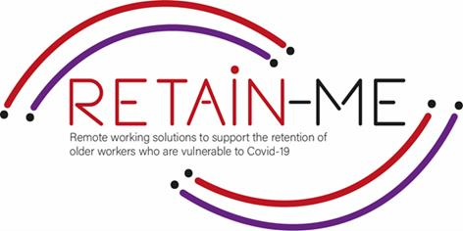



The purpose of these exercises is to help you in the pre-interview assessments and getting ready for the competitive interviews.

1. One of the first things you should do is find out more about the job you are applying for. If you are unsure if you are suitable for this specific job, write down all the pros and cons of working for this company!

JOB DESCRIPTION

………………………………………………….………………………………………………….……………………………………

………………………………………………….………………………………………………….……………………………………

………………………………………………….………………………………………………….……………………………………

PROS CONS

…………………………………………

…………………………………………

…………………………………………

…………………………………………

…………………………………………

…………………………………………

…………………………………………

…………………………………………

…………………………………………

…………………………………………

…………………………………………

…………………………………………

1. During an interview, you will be asked questions about your previous job experience and skills. You never know what exact questions you will be asked, but you can still prepare yourself beforehand. Try to answer the following questions. There is a high possibility that such questions will be during an interview.
   1. How do you stay motivated when working alone?

………………………………………………….………………………………………………….……………………………………

………………………………………………….………………………………………………….……………………………………

………………………………………………….………………………………………………….……………………………………

………………………………………………….………………………………………………….……………………………………

* 1. How do you limit distractions when you’re working?

………………………………………………….………………………………………………….……………………………………

………………………………………………….………………………………………………….……………………………………

………………………………………………….………………………………………………….……………………………………

………………………………………………….………………………………………………….……………………………………

* 1. What would you say are the best and hardest aspects of working with you?

………………………………………………….………………………………………………….……………………………………

………………………………………………….………………………………………………….……………………………………

………………………………………………….………………………………………………….……………………………………

………………………………………………….………………………………………………….……………………………………

* 1. What are your goals for the future?

………………………………………………….………………………………………………….…………………………………

………………………………………………….………………………………………………….……………………………………

………………………………………………….………………………………………………….……………………………………

………………………………………………….………………………………………………….……………………………………

*“Obstacles are those frightful things you see when you take your eyes off your goal.”*

*Henry Ford*



For more information, you may visit our website: <https://www.facebook.com/RetainMeErasmusProject> and our Facebook: <https://www.facebook.com/RetainMeErasmusProject>



2021-1-SE01-KA220-VET-000032922