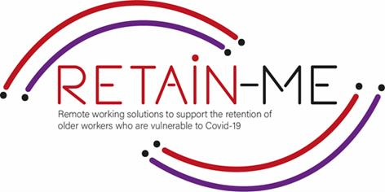



The purpose of these exercises is to understand the difference between soft skills and hard skills, and to estimate how good you are at each of the skills and what must be done to improve them.

1. Think about your past work performance and your personality traits, and try to estimate how good you are with the following soft skills:

|  |  |  |  |  |  |
| --- | --- | --- | --- | --- | --- |
| SOFT SKILL | 1 | 2 | 3 | 4 | 5 |
| TEAMWORK |  |  |  |  |  |
| CRITICAL THINKING |  |  |  |  |  |
| TIME MANAGEMENT |  |  |  |  |  |
| LEADERSHIP |  |  |  |  |  |
| CREATIVITY |  |  |  |  |  |
| ADAPTABILITY |  |  |  |  |  |
| STRESS MANAGEMENT |  |  |  |  |  |
| ORGANIZATIONAL SKILLS |  |  |  |  |  |
| COMMUNICATION |  |  |  |  |  |
| PROBLEM-SOLVING |  |  |  |  |  |

1. Now, think about the technical skills that you gained from education or training experience. Try to estimate how advanced you are with the following hard skills:

|  |  |  |  |  |
| --- | --- | --- | --- | --- |
| HARD SKILL | NONE | BASIC | INTERMEDIATE | ADVANCED |
| PROJECT MANAGEMENT |  |  |  |  |
| PROGRAMMING SKILLS |  |  |  |  |
| FOREIGN LANGUAGES |  |  |  |  |
| WRITING SKILLS |  |  |  |  |
| LOGISTICS |  |  |  |  |
| MARKETING |  |  |  |  |

1. Look up the list of other soft and hard skills online and write down below how advanced you are with them.

SOFT SKILLS

………………………………….………………………………….………………………………….

………………………………….………………………………….………………………………….

………………………………….………………………………….………………………………….

………………………………….………………………………….………………………………….

………………………………….………………………………….………………………………….

HARD SKILLS

………………………………….………………………………….………………………………….

………………………………….………………………………….………………………………….

………………………………….………………………………….………………………………….

………………………………….………………………………….………………………………….

………………………………….………………………………….………………………………….

*“Success isn’t always about greatness. It’s about consistency. Consistent hard work leads to success. Greatness will come.”*

*Dwayne Johnson*

For more information, you may visit our website: <https://www.facebook.com/RetainMeErasmusProject> and our Facebook: <https://www.facebook.com/RetainMeErasmusProject>



2021-1-SE01-KA220-VET-000032922