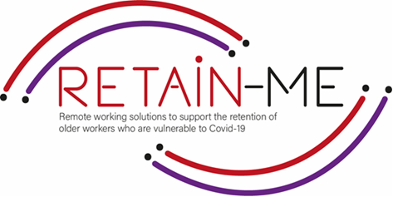

**EMBRACING CHANGE FACT SHEET**

**DEVELOPMENT OF TIME MANAGEMENT AND ORGANISATION SKILLS**

**Time Management**

Why is Remote Work Time Management Important?

Time management is one of the most important and difficult to manage aspects of remote work. When done right, remote work offers tremendous flexibility and increased productivity. However, poor time management can also make your remote environment very stressful and isolating at times. You might struggle to balance your work responsibilities with your personal ones. This is exactly why it’s important to be in control of your own workday in a home office.

Time management is a challenge during normal times, but when working remotely, it can be tougher without the parameters you’re accustomed to when you’re in the office.

Sometimes it feels like there isn't enough time and we've all probably put in some extra work hours in the evenings and weekends. Through Time management, you can learn to work smarter and get more out of your time, both at work and in your free time.

**Organisation Skills**

To properly organize your working day, start and finish work remotely at a strictly allotted time, take a food break and get up from your chair to warm up. Also, experts recommend not to stay in your pyjamas while working, even if none of your colleagues can see you.

Organize your workplace, when you work from a bed or sofa, it is not a good solution. It would be best to take care of your personal space, ideally an office where no one will interrupt you. Make sure you have a comfortable desk and chair to work with. Set up all the devices you need and connect to the most convenient and reliable internet.

To make it easier to organise your work It's good that you and your team have a clear plan of tasks, according to which you can work and, for example, at the end of the day, call the whole team and check where each of you is now.

# FACTS

# *“The bad news is time flies. The good news is you’re the pilot” -* *Michael Altshuler*

*Michael Altshuler*

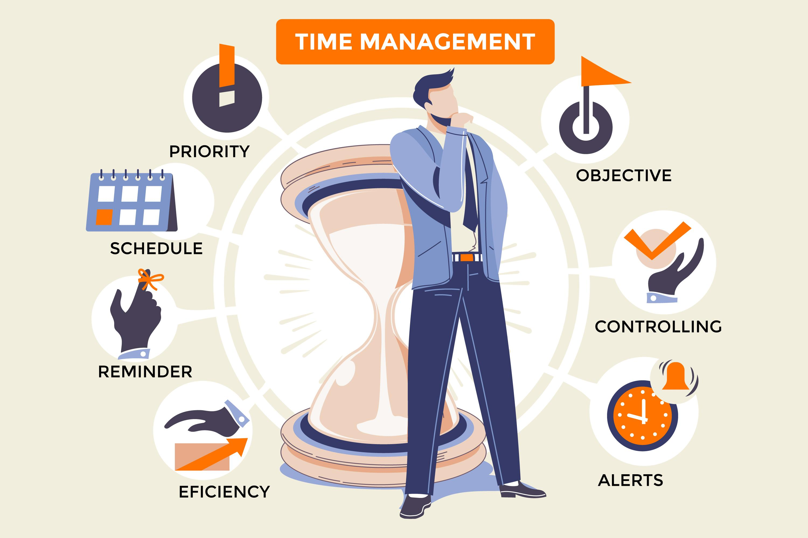

## FOR MORE INFORMATION

For more information about development of time management and organization skills, you may visit the following links:

* Time management strategies for remote workers

<https://timelyapp.com/blog/time-management-strategies>

* Easy Time Management Techniques for Remote Workers

<https://facilethings.com/blog/en/easy-time-management-techniques-for-remote-workers>

* Effective Time Management While Working Remotely During The COVID-19 Pandemic

<https://www.forbes.com/sites/hvmacarthur/2020/04/05/effective-time-management-while-working-remotely-during-the-covid-19-pandemic/>



2021-1-SE01-KA220-VET-000032922