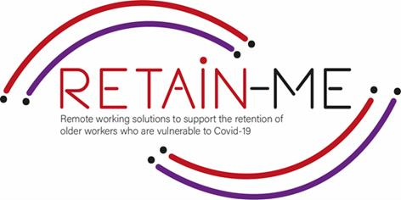

**SKILLS FOR REMOTE JOB SEEKING HOW TO ASSESS YOUR OWN SKILLS?**

# ASSESSMENT OF THE SKILLS

Assessment of your skills is vital if you are looking for a remote job. We often find ourselves busy with daily activities, forgetting that assessing our skills might help us understand ourselves better, which can later lead to a personal development. Moreover, once you truly understand yourself and you know what your skills are, you can also start a more promising career!

The assessment of your skills can help you improve and leverage the skills you already have, but also develop new ones that might be helpful for you in finding a new career path.

# HARD SKILLS

Hard skills are often referred to as technical skills - which means you gain them from education and training experience. The most popular hard skills are:

* Project management
* Programming skills
* Foreign languages
* Writing skills
* Logistics
* Marketing

# SOFT SKILLS

Some of the most critical professional skills cannot be taught in a classroom or measured on paper. Soft skills are more challenging to assess as they cover elements of your personality and traits. The most common soft skills:

* Communication
* Teamwork
* Problem-solving
* Critical thinking
* Organizational skills
* Time management
* Stress management
* Leadership
* Creativity
* Adaptability

# THE WAY TO ASSESS YOUR SKILLS

* Make a list of all your hard and soft skills.
* Rate your skills using a scale – it can be a scale of 1 to 10.
* Think about what you’ve always been good at.
* Ask your friends, family, ex-colleagues, ex-managers for feedback.
* Dive into your past performance reviews.
* In the end, prioritize what skills you want to work on!

*“Success isn’t always about greatness. It’s about consistency. Consistent hard work leads to success. Greatness will come.”*

*Dwayne Johnson*



FOR MORE INFORMATION



For more information on how to assess your soft and hard skills, you may visit the following links:

https://www.valamis.com/hub/hard-skills-vs-soft-skills

https://www.careeraddict.com/assessing-skills-career

https://blog.avilar.com/2020/05/20/what-is-a-skills-assessment-and-why-is-it- important/

https://iguideproject.eu/wp-content/uploads/IO1/iGuideIO1LearnerHandbookEN.pdf

2021-1-SE01-KA220-VET-000032922