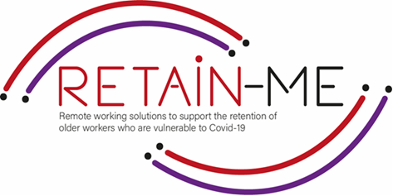

**EMBRACING CHANGE FACT SHEET**

**UNDERSTANDING VIRTUAL COMMUNICATION**

**SELF-REFLECTION EXCERCISES**

Today we use virtual communication in almost every work of life • within family, friends, and office to name a few. So its important to be aware about and understand virtual communication.

Self-reflection about the knowledge and what we need to improve concerning the virtual communication.

# FACTS

# Self-reflection is very important to know if we are understanding virtual communication

1. Indicate which statement is right and which is wrong

|  |  |  |
| --- | --- | --- |
| Statement | R | W |
| 1. You don’t need any knowledge about communication to understand virtual communication. |  | X |
| 1. Open, honest communication not only helps you to avoid misunderstandings | X |  |
| 1. Bombard your team with messages |  | X |
| 1. Virtual communication has a huge impact on productivity | X |  |
| Poor communication between remote teams increases the chances of things going wrong. | X |  |

1. Find the statement that does not indicate a good practice

to effective communication.

|  |
| --- |
| Get support with tools. |
| 1. Find good communication activities |
| 1. A friendly working environment where your team works together is necessary. |
| 1. Distractions at home. |
| 1. Clear communication |

1. Find what does not support virtual communication.

|  |
| --- |
| 1. Teambuilding |
| 1. Support |
| 1. Good tools |
| 1. Bad internet connections and video connections |
| 1. Gestures, facial expressions and body language |

# *“In a world that is constantly changing, it is to our advantage to learn how to adapt and enjoy*

# *something better.”- Kenneth H. Blanchard*



For more information, you may visit our website: <https://retain-me.eu/>

and our Facebook: <https://www.facebook.com/RetainMeErasmusProject>



2021-1-SE01-KA220-VET-000032922