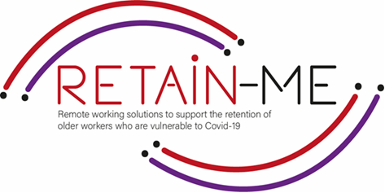

**EMBRACING CHANGE FACT SHEET**

**UNDERSTANDING VIRTUAL COMMUNICATION**

**Virtual communication definition**

We define virtual communication as a mode of communication that includes the use of technology - audio and video to communicate with people who are not physically present in front of us. People can be in the next room, other floor, in neighborhood or even miles away. Although virtual communication started way back with the invention of telephone, the advent of webcams, video conferencing and instant communications, which made virtual communication a big hit. Today we use virtual communication in almost every work of life • within family, friends, and office to name a few.

**Effective communication**

Effective communication is important within a virtual team. Open, honest communication not only helps you to avoid misunderstandings, but it will also increase your effectiveness.

It’s crucial to get communication right when you’re working remotely.

Why? Because virtual communication has a huge impact on productivity. When your team knows how to communicate well, they can get work done without waiting hours for a response. Plus, poor communication between remote teams increases the chances of things going wrong.

**Rules for better communication in virtual teams**

**Say “good morning”**

One of the biggest transitions employees face when working remotely is the lack of human interaction and the lack of structure.

A good place to start? Say “good morning” to each other and make time to chat over your morning coffee. It’ll help your remote team feel a little less remote.

**Build trust** in person and grow that trust with clear expectations. In order for people to work effectively virtually, there has to be trust. Trust doesn't happen magically. It is built when you bring your team together for training or team building, and then continues to grow with clear expectations consistently set by leaders and met by the team.

Try to **listen actively** when someone else is speaking, and never attempt to multitask. Give the other person your full attention – this is a sign of respect, and you'll understand them better, too.

# FACTS

# *“In a world that is constantly changing, it is to our advantage to learn how to adapt and enjoy something better.”- Kenneth H. Blanchard*



## FOR MORE INFORMATION

For more information about understanding virtual communication, you may visit the following links:

* 7 ways to communicate effectively in virtual meetings

<https://infinitegrowth.com.au/7-ways-to-communicate-effectively-in-virtual-meetings>

* Virtual Communication: An In-Depth Guide On Tips & Tools

<https://www.glasscubes.com/virtual-communication/>

* Working in a Virtual Team

<https://www.mindtools.com/pages/article/working-virtual-team.htm>



2021-1-SE01-KA220-VET-000032922