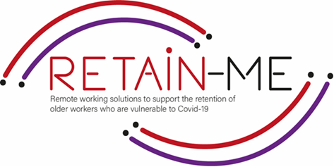

**EMBRACING CHANGE FACT SHEET**

**ABILITY TO WORK REMOTELY IN A TEAM**

**SELF-REFLECTION EXCERCISES**

The employers should have time and opportunities to self-reflect and create an awareness of their situation concerning the ability to work remotely in a team.

Self-reflection is very important to know if we have ability to work remotely in a team and what we need to improve and were can the knowledge increase.

# FACTS

# Self-reflection is very important to know if we have ability to work remotely in a team.

1. Indicate which statement is right and which is wrong

|  |  |  |
| --- | --- | --- |
| Statement | R | W |
| 1. You don’t need any discipline to work remotely in a team. |  | X |
| 1. Clear communication is important. | X |  |
| 1. Bombard your team with messages |  | X |
| 1. Problem-solving is a good skill to have. | X |  |
| Strong time-management skills are also essential to remote work | X |  |

1. Find the statement that does not indicate a good practice

to have ability to work remotely in a team

|  |
| --- |
| Get support with tools. |
| 1. Find the positive aspects of teamwork. |
| 1. Have teambuilding activities. |
| 1. Start worrying and panicking. |
| 1. Relax |

1. Find what does not support to work remotely in a team

|  |
| --- |
| 1. Teambuilding |
| 1. Support |
| 1. Good tools |
| 1. Bad communication |
| 1. Establish a routine |

# *“Coming together is a beginning; keeping together is progress;*

# *working together is success.”*

# *Henry Ford*

# 



For more information, you may visit our website: <https://retain-me.eu/>

and our Facebook: <https://www.facebook.com/RetainMeErasmusProject>



2021-1-SE01-KA220-VET-000032922