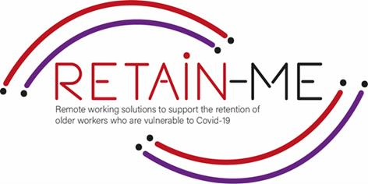

**SKILLS FOR REMOTE JOB SEEKING HOW TO PRESENT YOURSELF DURING AN ONLINE INTERVIEW?**

Job interviews have always been daunting for employees of all experience levels because they include a fast first impression and could put you on the spot to prove yourself. Interview online can be even more stressful; however, there is still several ways to make yourself look professional and make an excellent first impression online.

# A PROPER BODY LANGUAGE

An engaging body language during the interview will help you answer confidently and with energy. Here you will find a list of things you should and shouldn’t do:

* **Do not slouch!** Slouching can make you feel tired and want to be already done with the interview.
* **Do not cross your arms or legs!** Crossing your arms or legs will make you look like you are not fully engaged and can cause a mental block that makes it hard to really take in the information.
* **Keep an eye contact!** Instead of looking at the person on the screen, look directly into the webcam and stay engaged. It can be tricky to look at the camera when you see a person on the screen.
* **Smile and look genuine!** It’s important to have a confident and genuine smile as you kick off the interview. Moreover, while the hiring manager is speaking, it’s important to look interested, focused, and in general, have a pleasant expression on your face.
* **Remember about the right tone of voice!** A confident and enthusiastic tone of voice will make you less nervous. Just relax and remember to breath.
* **Dress up smart!** A put-together outfit can make a strong impact on a recruiter, even if the interview is online. Dress from head to toe as you would have an in-person interview! It will make you feel more confident!

# BEING CONFIDENT HELPS!

Remember that you want to come across as genuine and authentic during an interview. That is your opportunity to express yourself off the paper. Now you get to show who you are as an individual!

A proper body language is essential, but you also need to remember about other ways to seem professional. Stop and think deeply about your strengths, weaknesses, and traits. You can make a list ahead of time to organize your thoughts. These are likely going to be questions asked during the interview anyways. When you know what you want to communicate, you’ll find it easier to let your strengths naturally shine through.

By trying to present yourself as a professional and well-behaved person, you give yourself the best possible chance at making a success of your transition to a remote working career. Prepare yourself beforehand and be yourself, as it is a perfect way for you to make good first impressions and start a new career path online.

*“Two things remain irretrievable: time and a first impression.” Cynthia Ozick*



FOR MORE INFORMATION





2021-1-SE01-KA220-VET-000032922