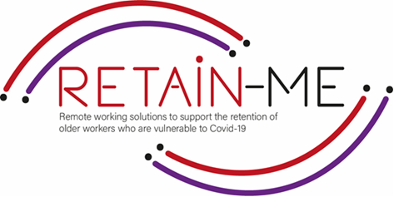

**EMBRACING CHANGE FACT SHEET**

**DEVELOPMENT OF TIME MANAGEMENT AND ORGANISATION SKILLS**

**SELF-REFLECTION EXCERCISES**

The ability to successfully manage your own time is an invaluable skill to have, benefiting both yourself and your employer. It’s up to you to stay focused on your work and ensure that you complete everything that’s assigned to you.

Self-reflection about time management and organisation skills can show if you need to develop the skills.

# FACTS

# Self-reflection is very important for development of time management and organization skills

1. Indicate which statement is right and which is wrong

|  |  |  |
| --- | --- | --- |
| Statement | R | W |
| 1. Time management is a good hard skill. |  | X |
| 1. Time management is the number one soft skill required to work efficiently working remotely. | X |  |
| 1. Stay in your pyjamas while working from home. |  | X |
| 1. Remote jobs can offer a lot of flexibility. | X |  |
| To organize your work, It's good that you and your team have a clear plan of tasks, | X |  |

1. Find the statement that does not indicate a good practice

to effective time management.

|  |
| --- |
| Get support with a to do list |
| 1. Don’t track your time |
| 1. Plan your time. |
| 1. Block your distractions |
| 1. Manage the deadlines |

1. Find what does not support organization skills.

|  |
| --- |
| 1. Distractions at home. |
| 1. Discipline and mindset are good organisation skills. |
| 1. Have a workplan. |
| 1. Be prepared for challenges. |
| 1. Can not follow deadlines. |

*“The bad news is time flies. The good news is you’re the pilot” - Michael Altshuler*



For more information, you may visit our website: <https://retain-me.eu/>

and our Facebook: <https://www.facebook.com/RetainMeErasmusProject>



2021-1-SE01-KA220-VET-000032922