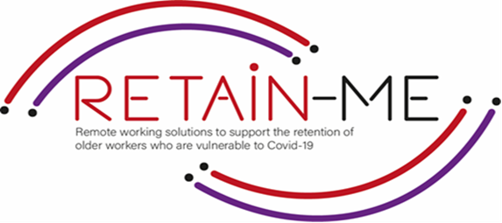

**Conducting research into remote working**

**SELF-REFLECTION EXCERCISES**

In the course of our lives, we are faced with numerous decisions to make, it is always useful to have as much information available to us before we make any decision, this is where the research process comes into play

By conducting accurate and relevant research we can learn a lot about a topic and use the information we have collected to make decisions that suit us best, this applies to careers as well. Relevant research opens many doors in your job search and should always be a jumping off point in the process.

The Point of this self-reflection exercise is for you to question your research process and to identify areas in which you are doing well and areas that need improvement

1. Have you kept an open mind during your research process and explored all the opportunities available to you?

|  |
| --- |
|  |
|  |
|  |
|  |
|  |

|  |
| --- |
|  |
|  |
|  |
|  |
|  |

1. Have you been accurate and consistent in your research, in a way that will
2. most benefit your job search.
3. Have you been mindful of the sources of information and possible biases they might hold.

|  |  |
| --- | --- |
|  |  |
|  |  |
|  |  |
|  |  |
|  |  |

# *“Research means that you don’t know, but are willing to find out”*

# *Charles F. Kettering*

# 

For more information, you may visit our website: <https://www.facebook.com/RetainMeErasmusProject>

and our Facebook: <https://www.facebook.com/RetainMeErasmusProject>



2021-1-SE01-KA220-VET-000032922