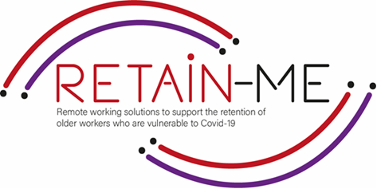

**EMBRACING CHANGE FACT SHEET**

# **Resource 1: Conducting Research**

# **Conducting Research**

# Conducting research is a vital part of finding a remote work job, in the first instance you need to assess what kind of job you are interested in, this begins with a broad evaluation of the opportunities available. You may find that there are jobs that match your interests and abilities that you have never heard of or imagined. That’s why it's important that when you begin researching to keep as open a mind as possible.

# **Benefits of Conducting Research**

# The Benefits of conducting research are widespread but a few examples include, Research improves your knowledge of a subject and increases your chances of finding a job that suits both your interests and abilities, Research reduces the chances that you make a bad choice as you have more information on hand to use in the decision making process, By conducting research you will have a greater idea of what salary to expect and more knowledge to express during the interview process

# **Tips for Conducting research**

# Start with an open mind and cast a broad net

# Identify possible sectors of interest or areas that are suited to your ability

# Focus your research in more depth in roles that you are interested in

# Evaluate your qualifications and preparedness for roles you are researching

# Understand that information provided by the employer is used to paint them positively

# Find the reality of working in a chosen role and not just how you imagine it is

# Use established job notice boards to see available roles

# In the case of an interview, research in depth on the organisation you are interviewing for and the role you have applied for

# FACTS

# *“Research means that you don't know but are willing to find out”*

# *Charles F. Kettering*

# 

# 

FOR MORE INFORMATION

# For more information on how to become more adoptable to changes in remote working contexts, you may visit the following links:

* <https://www.indeed.com/career-advice/finding-a-job/how-to-research-career>
* <https://work.chron.com/career-research-important-4221.html>
* <https://www.wellesley.edu/careereducation/resources/how-conduct-career-research>
* <https://info.lse.ac.uk/current-students/careers/information-and-resources/looking-for-work/how-to-research-careers>
* <https://www.crac.org.uk/>



2021-1-SE01-KA220-VET-000032922