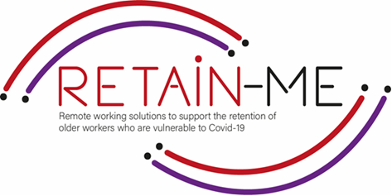

**EMBRACING CHANGE FACT SHEET**

# **BECOMING MORE ADOPTABLE TO CHANGES**

# **IN REMOTE WORKING ROLES**

**SELF-REFLECTION EXCERCISES**

# In the course of our lifetime, we are faced with numerous changes. We may find ourselves changing schools, jobs and homes, as well as friends, personal items, etc. It goes without saying that the change is inevitable in our life.

# Humans are not always comfortable when facing change(s). They actually tend to fear and resist change because it comes out of the blue and it pushes us outside our comfort zones. What turns to be helpful in these situations is to have a flexible attitude, not to panic, not to worry much and adopt as soon as possible in a smooth way.

# Becoming more adoptable to changes in remote working roles is critical. It is important to be able to reduce our level of fear, anxiety and stress and know to accommodate, change our point of view and adapt smoothly and successfully to a new situation or environment.

# We should always keep in mind that changes will help us to grow personally and professionally, and make us more flexible and adoptable, helping us value small things in our everydayness and new opportunities in our life paths.

Remote working is a new change nowadays that will remain in the future, even after the pandemic/ Covid-19 days. Becoming more adaptable in remote working contexts is critical nowadays in maintaining effective processes and results.

# FACTS

# Self-reflection is very important to know if we are adaptable and always ready for

# new changes, or if we are firm and rigid and therefore, reluctant to change

1. Indicate which statement is right and which is wrong

|  |  |  |
| --- | --- | --- |
| Statement | R | W |
| 1. It takes 3 days for humans to adapt to change |  | X |
| 1. Two of the benefits of remote working are the following: flexibility and freedom. | X |  |
| 1. Three of the challenges of remote working ar the following: isolation, depression, frustration. | X |  |
| 1. It is said that remote working will increase in the years to come. | X |  |
| A step to take for successful remote working is to respectful of your routine but also try new things | X |  |

1. Find the statement that does not indicate a good practice

in becoming more adoptable to changes in remoting roles

|  |
| --- |
| Recognise that change is happening. |
| 1. Find the positive aspects. |
| 1. See what you may control. |
| 1. Start worrying and panicking. |
| 1. Relax |

1. Find what does not support working from home successfully

|  |
| --- |
| 1. Focus in your workspace. |
| 1. Work and life balance. |
| 1. Networking |
| 1. Isolation |
| 1. Establish a routine |

# *“It is not the strongest or the most intelligent who will survive*

# *but those who can best manage change”*

# Charles Darwin

# 

# Embrace change Stock Photos, Royalty Free Embrace change Images | Depositphotos

For more information, you may visit our website: <https://www.facebook.com/RetainMeErasmusProject>

and our Facebook: <https://www.facebook.com/RetainMeErasmusProject>



2021-1-SE01-KA220-VET-000032922