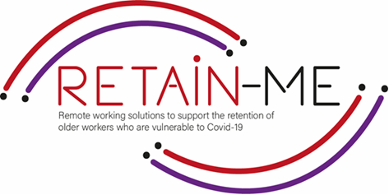

**EMBRACING CHANGE FACT SHEET**

# **BECOMING MORE ADOPTABLE TO CHANGES**

# **IN REMOTE WORKING ROLES**

# **ON REMOTE WORKING**

# When working remotely, we do our job at a place outside the official working location of our employer. Such environments might be other offices, a cafeteria, our home, etc.

# **BENEFITS OF REMOTE WORKING**

# Be more flexible

# Gain freedom over working environment

# Increase productivity and performance levels

# Avoid office politics

# Be away from seasonal flue, remaining healthy

# Avoid traffic and crowds

# Save money, minimize costs

# Spend more time with family

# **WORKING REMOTELY CHALLENGES**

* Lack of social contact and others support, leading to isolation and even depression
* Frustrations with family members who might also work from/ be at home
* Musculoskeletal issues/ challenges from poor workstation set up
* Unbalance between work and life.

# **EMBRACING CHANGE**

# A key in remote working is embracing change. Changes are challenging, even if they are mostly welcome and adapting to changes is a process. From what we know, our habits can determine how we perceive and react to change. For example, if we habitually think negatively about new situations or new people, then we will react in a negative way towards change. Interestingly, specialists say that it only takes 21 days to adapt to new changes and take on new habits**,** so within 21 days we may get used to change(s).

# **ADAPTING TO CHANGE SUCCESSFULLY**

# Acknowledge that change is happening

# Identify the positive aspects

# Prepare, if possible

# Focus on what you can control

# Calm and relax

# **HOW TO SUCCEED WORKING FROM HOME**

# Create a defined workspace in order to focus

# Separate work from life to avoid burnout

# Network and be with others to avoid loneliness

# Be respectful of your routine but also try new things

# Embrace change

# FACTS

# *“It is not the strongest or the most intelligent who will survive*

# *but those who can best manage change”*

# Charles Darwin

# 

# Embrace change Stock Photos, Royalty Free Embrace change Images | Depositphotos

## FOR MORE INFORMATION

# For more information on how to become more adoptable to changes in remote working contexts, you may visit the following links:

* <https://www.forbes.com/sites/forbesbusinesscouncil/2020/04/14/how-to-adapt-to-remote-work/>
* <https://www.indeed.com/career-advice/career-development/adapting-to-change>
* <https://whatfix.com/blog/adapt-to-change/>
* <https://www.lifehack.org/372463/why-you-need-adapt-change>
* <https://culturallyours.com/2018/12/12/5-ways-to-adapt-to-change-in-your-life/>



2021-1-SE01-KA220-VET-000032922