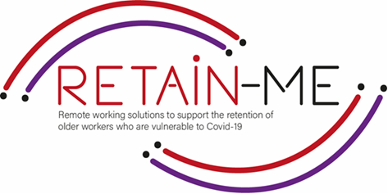

**EMBRACING CHANGE FACT SHEET**

**IMPROVE ABILITY TO APPLY DISCIPLINE**

**SELF-REFLECTION EXCERCISES**

One definition is: "The ability to do what you need to do, when you need to do it, whether you feel like it or not."

Self-discipline is about, among other things, precisely the ability to postpone or forego an immediate reward. After you have done the hard and necessary work, you will reap bigger and better fruits. You will probably also respect yourself more, your self-esteem increases, you feel proud. Research and studies have shown that those who have the discipline to postpone or forgo an immediate reward in order to instead get something better later in time are usually the most successful.

Self-reflection about the knowledge and what we need to improve ability to apply discipline.

# FACTS

# Self-reflection is very important to know if we need to improve ability to apply discipline.

1. Indicate which statement is right and which is wrong

|  |  |  |
| --- | --- | --- |
| Statement | R | W |
| 1. Before you can become more disciplined, you don’t need to be more observant of what you do and don't do today. |  | X |
| 1. Self-discipline helps us be more consistent so that we can achieve greater goals. | X |  |
| 1. Self-discipline is something you cannot learn and practice every day. |  | X |
| 1. It is your commitment to the goals that will keep you on the right path. | X |  |
| Self-discipline is something you can learn - it's not innate. | X |  |

1. Find the statement that does not indicate a good

self-discipline.

|  |
| --- |
| Track Your Progress |
| 1. Don’t set up goals. |
| 1. Don’t Stay in Your Pajamas when working from home. |
| 1. Establish and Maintain a Routine. |
| 1. Set Ground Rules with Family and Friends |

1. Find what does not support self-discipline.

|  |
| --- |
| 1. To pep yourself up. |
| 1. Commitment to your goals and values. |
| 1. Awareness of the situation. |
| 1. You don’t need to decide routines. |
| 1. Self-awareness. |

# *"Self-discipline is the ability to make yourself do what you should do when you should do it, whether you feel like it or not."*

*-Elbert Hubbard.*



For more information, you may visit our website: <https://retain-me.eu/>

and our Facebook: <https://www.facebook.com/RetainMeErasmusProject>



2021-1-SE01-KA220-VET-000032922