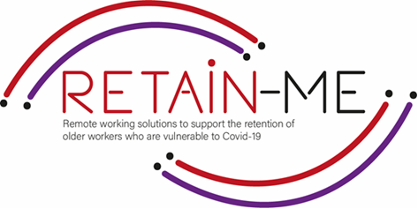

**EMBRACING CHANGE FACT SHEET**

**Improve ability to apply discipline**

**What is self-discipline?**

One definition is: "The ability to do what you need to do, when you need to do it, whether you feel like it or not."

Self-discipline is about, among other things, precisely the ability to postpone or forego an immediate reward. After you have done the hard and necessary work, you will reap bigger and better fruits. You will probably also respect yourself more, your self-esteem increases, you feel proud. Research and studies have shown that those who have the discipline to postpone or forgo an immediate reward in order to instead get something better later in time are usually the most successful.

**Self-discipline is something you can learn - it's not innate.**

That's why you can laugh the next time someone says he/she is self-disciplined. The fact is that one cannot be self-disciplined. One can use self-discipline, but one cannot be self-disciplined as if it were an innate quality. Even those who seem to be good at self-discipline also have issues with that little person inside them who takes over sometimes. The reason for that is that no matter how good you are at self-discipline, there is always room for improvement. Self-discipline is thus something you can learn and practice every day.

**Self-discipline**

As a remote worker, you must put more effort into staying focused. From frequent interruptions from family and friends to noisy neighbors to the strong urge to jump back to bed, there are myriads of distractions around you, and it can be tough to maintain the level of productivity you show in the 9-5 office setting.

That’s why it’s important to learn how to discipline yourself when working from home.

Self-discipline encourages us to do activities we should be doing, even when we don’t feel like doing them. That way, self-discipline helps us be more consistent so that we can achieve greater goals.

# FACTS

# *"Self-discipline is the ability to make yourself do what you should do when you should do it, whether you feel like it or not."*

# *-Elbert Hubbard.*



Image by pikisuperstaron Freepik

## FOR MORE INFORMATION

For more information about improve ability to apply discipline, you may visit the following links:

* Can You Encourage Self-Discipline in Remote Workers

<https://arc.dev/employer-blog/encourage-self-discipline-in-remote-workers/>

* Proven Ways to Develop Self Discipline While Working Remotely
* <https://hygger.io/blog/ways-to-develop-self-discipline-working-remotely/>
* Tips for maintaining a good remote work schedule
* <https://artofworkingremotely.com/topics/discipline/tips-for-maintaining-a-good-remote-work-schedule/>



2021-1-SE01-KA220-VET-000032922