Lesson Plan Template
Toolkit Topic: Introduction to remote work
Description of the Learning Activities | Duration | Materials or Equipment Required | Learning Outcomes Addressed and Assessment
Workshop Opening:  - The facilitator opens the workshop by welcoming all learners and presenting the topic Introduction of remote work and the topics that will be talked about during the module.  Activity 1: Icebreaker - Does remote work benefit a company?  - The facilitator would promote a reflection on the benefits of remote work in a company and would ask the opinion of the participants on this topic.  - Present slide 4 – the quote – and ask the participants to share their opinion about the quote. | 5 minutes  10 minutes | Training venue with IT equipment.  Flipchart and markers.  Sign-in sheet for the workshop.  Pens and note-taking materials for all participants.  Projector and screen.  Laptop.  PowerPoint Introduction to remote work - slides 2 to 4 | Awareness of the change for remote work.  Awareness of the realities of remote work.
Activity 2: Fact or belief?  - The facilitator presents the topics – What is remote work and the remote work statistics.  The slide of statistics explains that the research proves the positive impact remote work can have on both employees and businesses.  Understanding how remote work impacts your teams will help you better address potential problems and prioritize the things that matter most to your employees—and that will make the biggest difference in long-term performance and engagement.  - The facilitator presents the topic - How to engage remote employees and Culture-boosting remote working tools and introduces activity 2: fact or belief?  - Activity 2: Fact or belief? - The Facilitator asks the group to think of possible barriers that may exist to working at a distance and to write them on post-its.  - On a whiteboard, the Facilitator writes a column of barriers where participants will place their stick notes of possible barriers to remote work.  - Then the facilitator writes a second column, asking participants to classify each barrier as either a Fact or a Belief.  - Once all the barriers are ranked, the Facilitator explains that facts are great because they tell us what our implementation strategy is.  - For each fact, participants have to come up with one or two strategies to deal with it. For example lack of communication and how to improve team communication.  - The Facilitator then explains that for beliefs, they need to come up with a new, more positive belief. Still, something they could possibly believe in, but more positive. For example, employees will decrease their productivity. and switch to: let's promote more informal conversations between teams to figure out how we can improve productivity. | 10 minutes  15 minutes | Training venue with IT equipment, and space to break-out into smaller groups.  Flipchart and markers.  Projector and screen.  Laptop.  Pens and note-taking materials for participants.  Stick notes  PowerPoint Introduction to remote work - slides 5 to 12 | Understand what remote work is.  Acknowledge potential barriers for remote work and process them in a way that leads to confidence and ability to overcome them.  Knowledge of tools to enhance remote work objectives.  Promote the thinking about the varied demands of working remotely and how they differ from an in-office experience.
Activity 3: My teamwork is…  - The facilitator presents the topic – benefits of remote work for business and challenges and how to overcome them and the different types of remote work.  - After the presentation of the PowerPoint, explain activity 3 – My teamwork is…  - Activity 3: My teamwork is…. – After the presentations about the types of remote work, the participants will choose 1 type of remote work to start with their team and will explain why. | 10 minutes  10 minutes | Training venue with IT equipment, and space to break-out into smaller groups.  Flipchart and markers.  Projector and screen.  Laptop.  Pens and note-taking materials for participants.  PowerPoint Introduction to remote work - slides 13 to 28 | Knowledge of the benefits and the challenges, and how to overcome them.  Identify the different models of remote work.  Evaluate different remote work models and assess which are most relevant to one’s own business.
Activity 4: Welcome to my team  - The facilitator introduces the topic of onboarding for remote workers and shows the video: Tips for Onboarding Remote Employees - YouTube  - After the video, the facilitator explains activity 4: Welcome to my team. – the learners will create a template/guide for onboarding remote employees for their company with the objective to know the employee better.  - The facilitator explains the importance of the remote onboarding process for the integration of new employees. For the exercise, the facilitator can guide the learner with the following tips and questions:  - Expectations and goals should be made as clear as possible.  - Encouraging peer mentoring so that new employees have someone to turn to if they are having trouble with anything.  - Making your new remote employees feel welcome.  - When will onboarding begin and how long will it last?  - What sort of impression do you wish to leave on your new hires’ first day?  - What role will different people play in onboarding?  - What goals will you set for a new employee?  - What is important for the new employee to know about the work culture?  - What do you need to answer and do at the beginning of the process (prior to start? On the first day? In the first week? First month?  At the end of the exercise give the learners the Annex 1 – Onboarding Process Template and discuss the exercise.  For this exercise, the learners don’t need to create specific tasks and explain them in detail. It is important to take notes and ideas in a general way. | 5 minutes  20 minutes | Training venue with IT equipment, and space to break-out into smaller groups.  Flipchart and markers.  Projector and screen.  Laptop.  Columns.  Pens and note-taking materials for participants.  PowerPoint Introduction to remote work - slides 29 to 33  Copy of Activity Sheet - Onboarding checklist | Willing to undertake additional research and find remote working models that could work for one’s own business
Workshop Close and Feedback  - The facilitator brings the workshop to a close with a short wrap-up activity – My next move.  - The learners think of one remote strategy that they would like to implement in their company and share it with the group. | 5 minutes | Training venue with IT equipment and space to break out into smaller groups.  PowerPoint Introduction to remote work - slides 34 and 35
Total duration of the module | 90 minutes

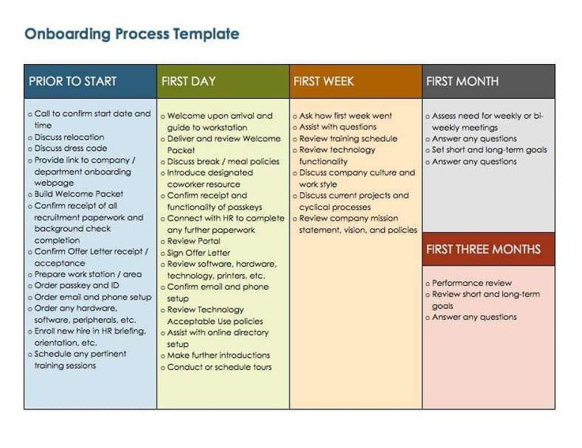
Annex 1 – Example of onboarding process template

Source: https://in.pinterest.com/pin/848013804831615795/
References
1- Wang, B., Liu, Y., Qian, J., & Parker, S. K. (2021). Achieving Effective Remote Working During the COVID-19 Pandemic: A Work Design Perspective. Applied psychology = Psychologie appliquee, 70(1), 16–59. https://doi.org/10.1111/apps.12290
2- S. Anna. miro. Introduction to Remote Work & Collaboration. [S.l.]. 2020. Available at: https://miro.com/guides/remote-work/ Access at: 25 mai. 2022.
3- CLAUDINE, McCarthy,. Implement success strategies for supervising staff members working remotely. Enrollment management report, [s. l.], jul. 2020
4- H.Joan. Working from home? Follow these tips for successful remote work. May.2020
5- G. Pamela. What are the benefits and challenges of remote working for global businesses?. Available at: What Are The Benefits and Challenges of Remote Working for Global Businesses? (cardinus.com) Access at: 18.july.2022.
6- G.Henseke., F, Alan. Assessing the growth of remote working and its consequences for effort, well-being and work-life balance. New technology, work and employment, [s. l.], oct. 2017

